Practical No. 8
Develop application to consume Google’s search / Google’s Map RESTful Web service.

1. First of all we need to create an Java Web Application with any name, let it be GoogleMap here using Netbeans IDE.
2. The code inside the input.jsp will be similar to this input.jsp Input.jsp

<!DOCTYPE html>
<html>
<head>
<meta http-equiv="Content-Type" content="text/html; charset=UTF-8">
</head>
<body>
<h1>Faisal Mulla 6015</h1>
<form action="index.jsp" method="POST">
<pre>
Enter latitude:<input type="text" name="t1" />
Enter longitude:<input type="text" name="t2" />
<input type="submit" value="Show" />
</pre>
</form>
</body>
</html>

3. Before running the application we need the Google API key. The steps are shown here:- Visit Google APIs Console (https://console.developers.google.com, you have to login with your Google account).

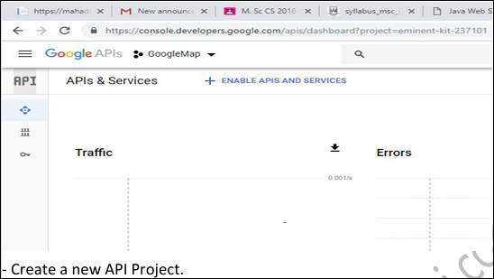
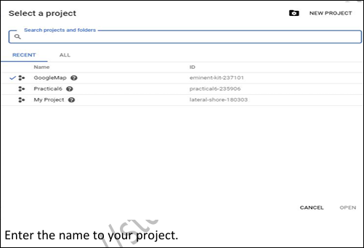

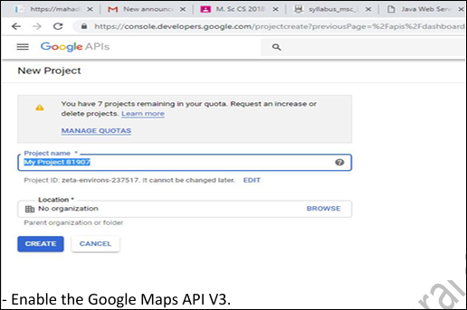

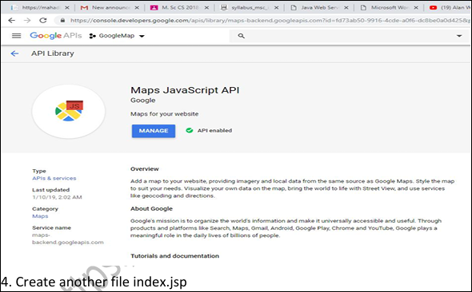

The above images are limited… Try to look around yourself on the Google Cloud Console website. You’ll have to make an account there. Enable 2 factor Authentication. Set up the billing account.. (what we know that works is an autopay set up from a google pay account. You are free to try other means, you must have 15000rs in your account (you wont be charged but this is needed for verification.) Google provides $200 credit monthly and this practical wont even consume a fraction of it so chill.. Once the billing is done its childs play to create an api key for the practical(search for maps). Don’t restrict the key, select “None” but also make sure to not expose your key anywhere.

Index.jsp:
<!DOCTYPE html>
<html>
<head>
<meta http-equiv="Content-Type" content="text/html; charset=UTF-8">
<title>JSP Page</title>
<style>
#map{
height: 400px;
width: 100%;
}
</style>
</head>
<body>
<%
double lati=Double.parseDouble(request.getParameter("t1"));
double longi=Double.parseDouble(request.getParameter("t2"));
%>
<h3> Google Maps</h3>
<h4> Faisal Mulla 6015</h4>
<div id="map"></div>
<script lang="javascript">
function initMap() {
var info={lat: <%=lati%>, lng: <%=longi%>};
var map =new google.maps.Map(document.getElementById('map'),
{
zoom: 10, center: info
});
var marker = new google.maps.Marker({
position: info,
map: map
});
}
</script>
<script async defer
src="https://maps.googleapis.com/maps/api/js?key=YourApiKeyHere&callback=initMap">
</script>
</body>
</html>
In the final script tag where it says “YourApiKeyHere” replace it with your 39 character API key. (between the ‘=’ sign and the ‘&’ sign)
Output:
